input.doc Name:________________________

1) Given power function f(x) below, use the rules of shifting and stretching to determine the explicit equations for the other functions.
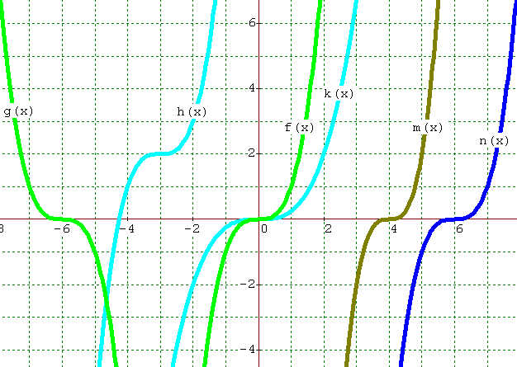
$$f(x)=x^{3}$$

$g(x)=$________________

$h(x)=$________________

$k(x)=$________________

$m(x)=$________________

$n(x)=$________________

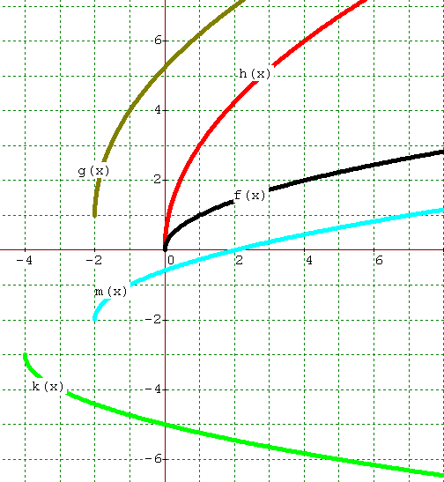
$$f(x)=\sqrt{x}$$

$g(x)=$________________

$h(x)=$________________

$k(x)=$________________

$m(x)=$________________

2) Make a sketch of the polynomial function $y=2(x−5)^{3}+1$. Then describe the roots of the function and try to find as many roots as you can!

